**Experimental report about**

**Using an Echo Application to Measure TCP Performance**

**Kebi Hong**

**CS 455**

**10/9/15**

**BUID 51913146**

**Introduction:**

In this experiment, we are going to compute an estimate value of Round-Trip-Time and the average Throughput using Echo client and server. We will set up a TCP connection between the echo client and server, then record the RTT we need to process a send-receive message exchange. We will use the following formula to compute the throughput. Also, we will exam the relationship between the RTT/ Throughput and the message size.

Throughput = Message size / RTT

**Experiment**

**RTT:** In order to collect data and graph TCP Round-Trip-Time VS Message size, I will use TCP to send and receive messages of size 1, 100, 200, 400, 800 and 1000 bytes. Data is collected under a local socket connection. I will send the same size of the message 10 times and compute the average as result. Server delay is 0.

|  |  |  |  |  |  |  |
| --- | --- | --- | --- | --- | --- | --- |
| Data Size | 1 byte | 100 bytes | 200 bytes | 400 bytes | 800 bytes | 1000bytes |
| RTT time | 0.0001400 | 0.0001581 | 0.0001474 | 0.0002287 | 0.0002693 | 0.0004064 |

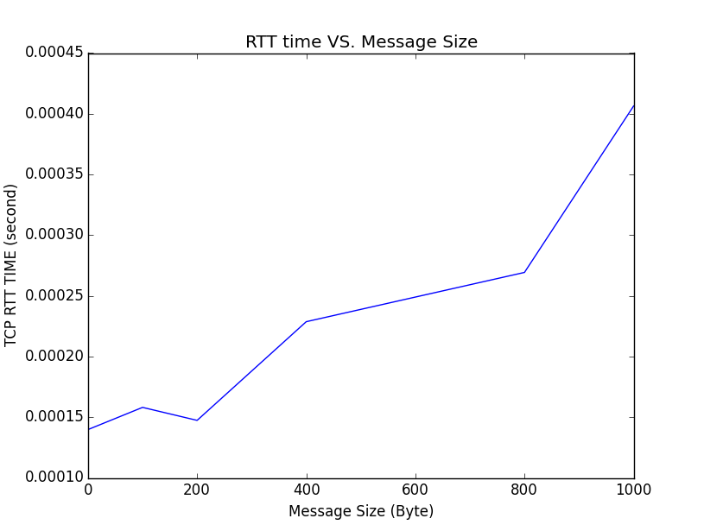

**Throughput:** In order to collect data and graph TCP Throughput VS Message size, I will use TCP to send and receive messages of size 1K, 2K, 4K, 8K, 16K, 32K bytes. Data is collected under a local socket connection. I will send the same size of the message 10 times and compute the average as result. Server delay is 0. Note: 1K byte = 2**10 = 1024 byte

|  |  |  |  |  |  |  |
| --- | --- | --- | --- | --- | --- | --- |
| Data size | 1024 bytes | 2048 bytes | 4096 bytes | 8192 bytes | 16384 bytes | 32768 bytes |
| Throughput  (kbps) | 6866.302 | 6273.308 | 11266.47 | 31441.95 | 52723.61 | 79663.50 |

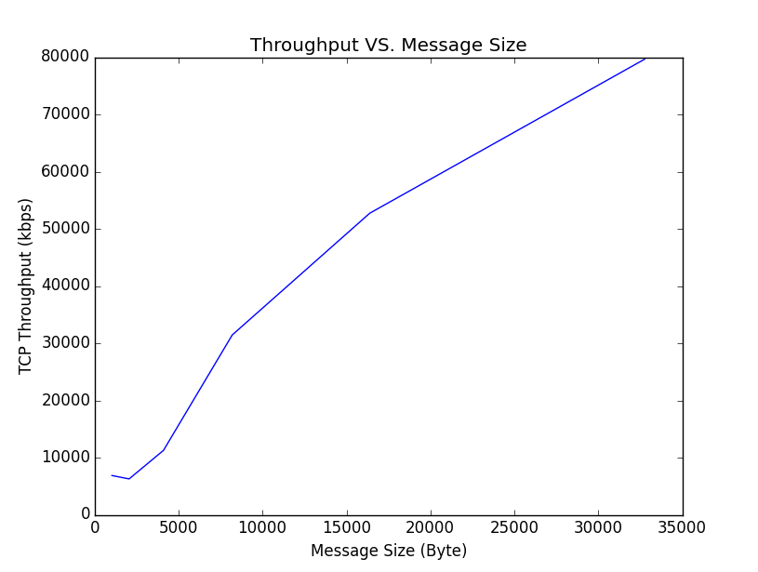

**Analyze:**

**Graph one:** According to the graph one, we can see that RTT is not sensitive to the change of the size of the message overall. If we compare the RTT data individually, at message size of 1 byte, RTT is around 0.15 ms, and RTT reaches to around 0.45 ms when the size of the message is 1000 byte. The RTT only increased 3 times as the size of the message increases 1000 times. Therefore we can say that RTT increases as the size of the message increase, but at a very slow rate.

**Graph two:** According to the graph two, we can see that Throughput is very sensitive to the change of the size of the message. When we send 1K byte message, the throughput is around 7000 kbps, and when we send 32K byte message, the throughput is around 80000 kbps. The size of the message increases 32 times, and the throughput increases more than 10 times. Therefore, the throughput is associated with the size of the message.